**AWS Task-1**

**Task Description:**

Create a windows Vm machine in AWS and connect with RDP open CMD in windows share the about system info.

Step 1:

Created Windows VM in AWS

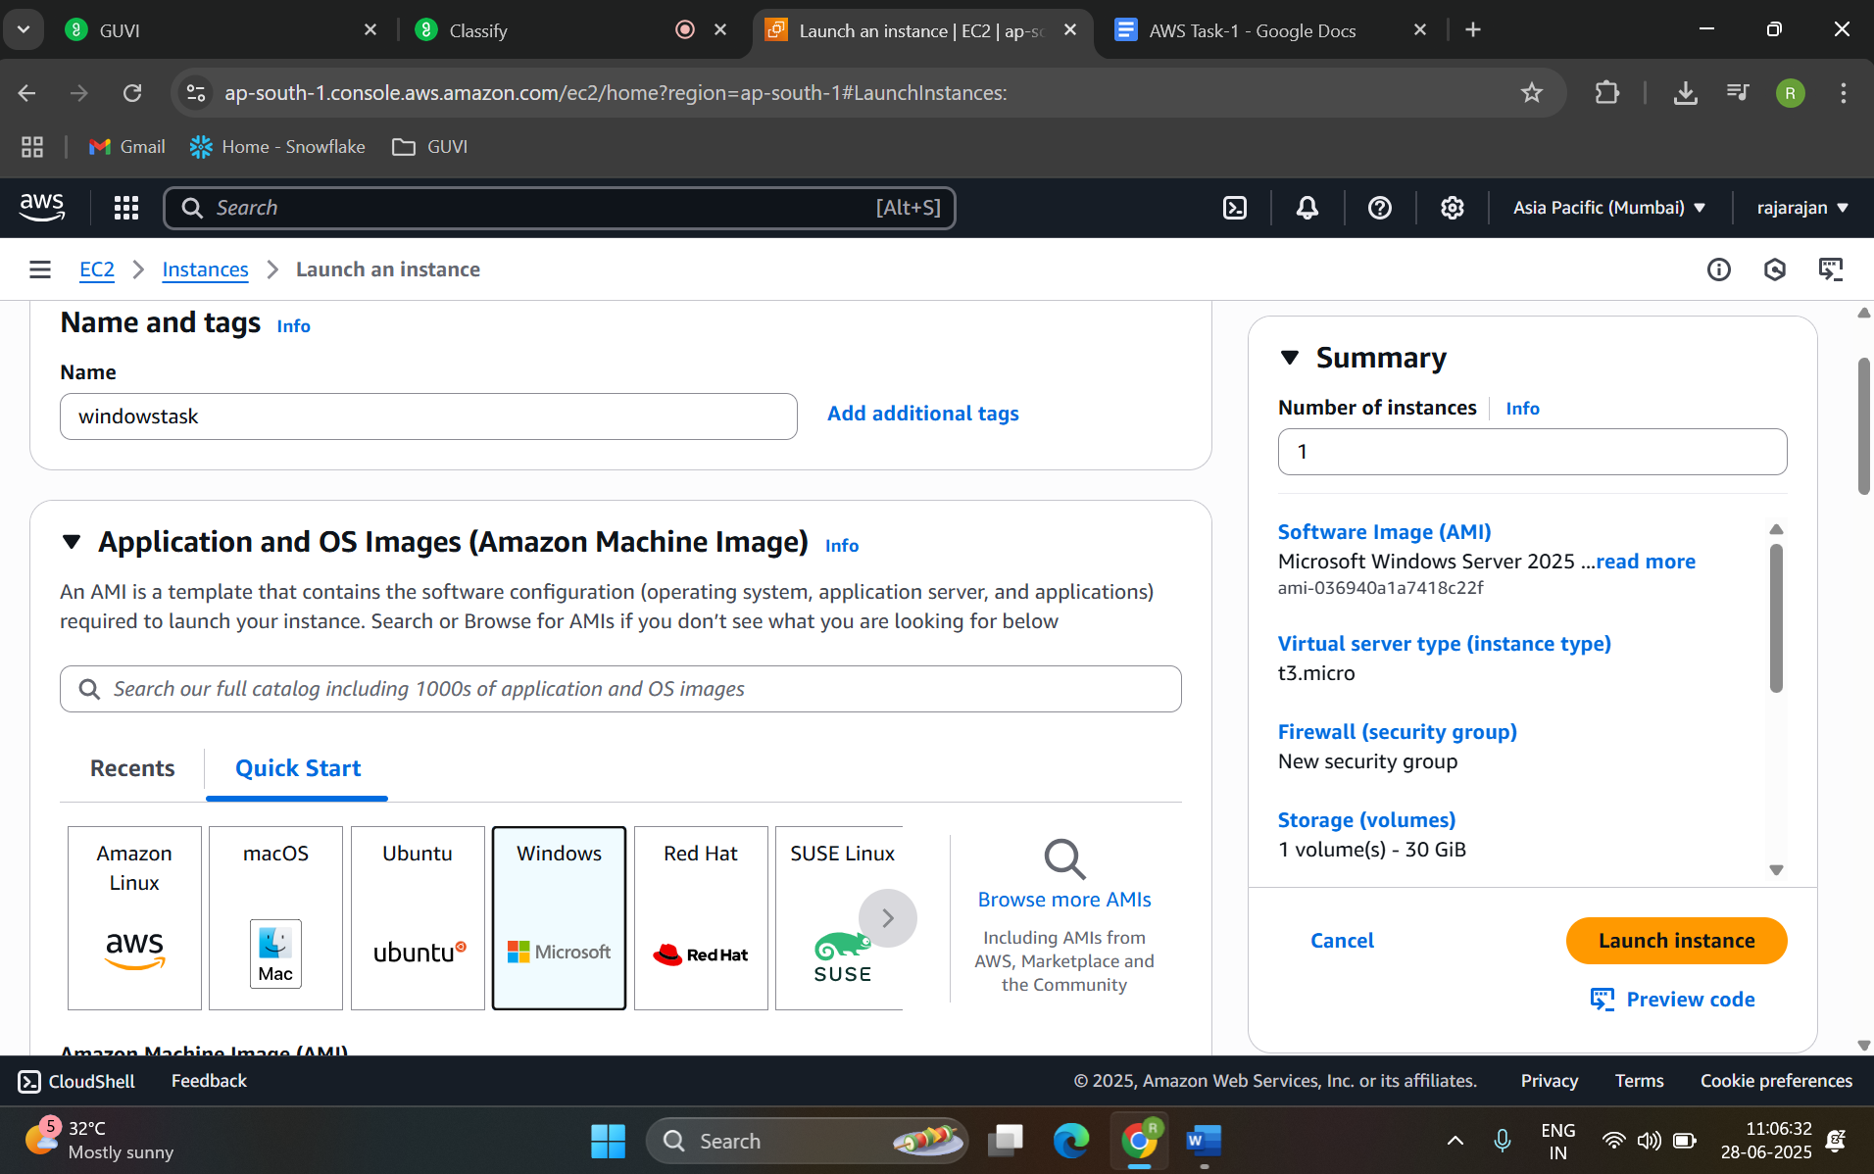

Step 2:

connected with RDP

